GREATER CAIRO METRO
LINE No.3 (Thawra Line)
TCMS-FDU interface specification

Approved by | 26.Mar.2019 | K.K. SHIN | 
Reviewed by | 26.Mar.2019 | S.J. SEO | 
Written by | 26.Mar.2019 | H.KIM | 
 | Date | Name | Signature

Revision History
Issue | Page | Revision |  | Date
Issue | Page | Contents | Reference | Date
0 | All | First issue |  | 26.Mar.2019
1 |  | TCMS-FDU-SDR port address was changed

Contents
1. INTRODUCTION 4
1.1. LIST OF ABBREVIATIONS 4
2. GENERAL 5
2.1. MVB Specification 5
2.2. MVB Connection 6
2.3. MVB Telegram 6
2.4. Train Formation of Cairo3 8
3. DATA EXCHANGE 10
3.1. TCMS → FDU SDR (Status Data Request) 10
3.1.1. TCMS-FDU-SDR 10
3.2. FDU → TCMS SD(Status Data) 12
3.2.1. FDU-TCMS-SD1 12
3.2.2. FDU-TCMS-SD2 13
3.2.3. FDU-TCMS-SD3 14

INTRODUCTION
This document describes the interface specification between TCMS(Train Control and Monitoring System) and FDU(Fire Detection System) for GREATER CAIRO METRO LINE No.3 (Thawra Line) project.

LIST OF ABBREVIATIONS
TCN Train Control Network
MVB Multifunction Vehicle Bus
EMD Electrical Medium Distance
WTB Wire Train Bus
TCMS Train Control and Monitoring System
CCU Central Control Unit
VCU Vehicle Control Unit
IO-M remote IO Module
VVVF Variable Voltage Variable Frequency
DU Display Unit
RTD Remote Transmission Device
DCU Door Control Unit
ATP Automatic Train Protection
EBCU Electrical Brake Control Unit
VAC Ventilation Air conditioner Controller
TCU Traction Control Unit
APU Auxiliary Power Unit
EVR Event Recorder
HCR Header Car Relay
MF Major Fault
MCF Major Complementary Fault
HSCB High Speed Circuit Breaker
LB Line Bus Switch
PB Parking Brake
EB Emergency Brake
HB Holding Brake
FSB Full Service Brake
AUTO Automatic Mode
ADB All Door Bypass
ADC All Door Closed
AAU Automatic Announcement Unit
DCU Display Control Unit(for PA/PIS)
BC Battery Charger
HCR Head Control Relay
SDR Status Data Request
SD Status Data

GENERAL

MVB Specification
General specification of MVB is described as follow.
-. Redundancy : Line A, Line B
-. Master / Slave : TCMS is only Master.
The subsystem needs not to act as bus administrator.
-. Media Support : EMD(Electrical Middle Distance) Communication Distance within 200m
<Table 1 Summary of the Multifunction Vehicle Bus by IEC 61375-1>
topology | bus(electrical)  star(optical)
Media | Electrical Short Distance  Electrical Middle Distance  Optical Glass Fibre | twisted wire pair, biased RS-485  shielded twisted wire pair, transformer coupled  200/240 µm fibres and star coupler
Length | Electrical Short Distance  Electrical Middle Distance  Optical Glass Fibre | 20 m, 32 devices per segment  200 m, 32 devices per segment  2000 m
Physical Redundancy | duplicated physical medium(synchronous send)
Signalling | Manchester II, 9-bit frame Start Delimiter
Signalling rate | 1.5 Mbit/s
Address space | 12-bit Device Address  (0…255 reserved for devices with Message Data capability)  12-bit Logical Address for Process Data  (each 16…256 bits)
Physical Addressing | single cast and broadcast
Frame size  (useful data) | 16, 32, 64, 128, 256 bits
Integrity | CRC-8 per 64bits + Manchester encoding, different frame Start Delimiter for Master Frame and Slave Frame against synchronization slip, reception time window supervision
Medium Allocation | by one centralized Master(Hyundai-Rotem’s CCU & VCU)
Traffic | periodic(mainly for Process Data)  sporadic(mainly for Message Data)  supervisory(for Supervisory Data)
Mastership Transfer | mastership transfer by token passing  serveral Bus Administrators can become Master in turn
Mastership Redundancy  (Option) | redundant Bus Administrators serve as back-up
Link Layer Service | Link Process Data Interface  Link Message Data Interface  Link Supervision Interface |  | broadcast of source addressed data  datagrams  Link Layer Management

MVB Connection
Where interchangeability is required, Subsystems connected by MVB shall be attached to the cable as follow:
<Table 2 Pin assignment for the EMD Connector>
1 | A.Data_P positive wire of Line A | 6 | A.Term_P, Positive pole of Terminator Line A
2 | A.Data_N negative wire of Line A | 7 | A.Term_N, Negative pole of Terminator Line A
3 | Not Used | 8 | B.Term_P, Positive pole of Terminator Line B
4 | B.Data_P positive wire of Line B | 9 | B.Term_N, Negative pole of Terminator Line B
5 | B.Data_N negative wire of Line B
Note 1 It is recommend to arrange the two connectors side by side on a device, Connector 1 on the left and Connector 2 on the right, to thread the wiring neatly.
Note 2 It may be necessary to ensure that the connector case is isolated from the device case if connection of the device cases is not advisable, for instance when large stray currents are expected.
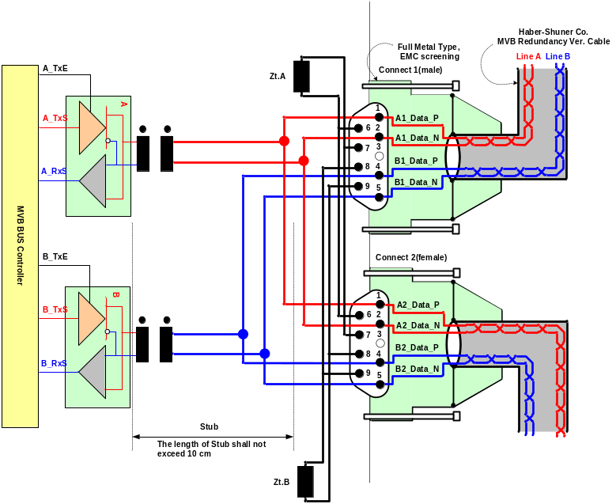
Figure 1 Double line EMD connector arrangement

MVB Telegram
There are 16 telegrams types on the MVB, which are distinguished by the F-code in Master Frame, as shown in Table 3.
Table 3 F-code of the MVB(Master Frame Type)

F-Code | Telegram Type
0 | Process Data Request with 16 bits
1 | Process Data Request with 32 bits
2 | Process Data Request with 64 bits
3 | Process Data Request with 128 bits
4 | Process Data Request with 256 bits
5 | (reserved)
6 | (reserved)
7 | (reserved)
8 | Mastership Transfer Request
9 | General Event Request
10 | (reserved)
11 | (reserved)
12 | Message Data Request
13 | Group Event Request
14 | Single Event Request
15 | Device Status Request
The basic data type for MVB network between TCMS and sub-system is WORD. Physical address is not used.
The byte ordering is the Big-Endian(Motorola) but, all data is read like word. So, the subsystem side must change like example.
The byte order and bit order for a data are as follows.
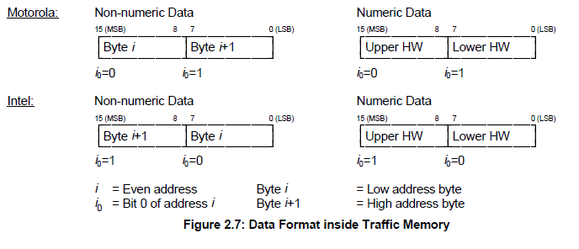
- MVB supervision :
The CCU is indicating the MVB state by the MVB watchdog counter that increases when the application is executed.
The counter from the MVB device is generated as soon as the application software is ready. If no MVB connection is established, i.e.
The MVB watchdog counter can not be received or an internal fault in the MVB device occurs, the signals, besides the watchdog counter, shall be had default value.
<Bit Ordering>
Data structures shall be numbered from left to right and from top to bottom, in the order of reading an English text. The first item on the top and to the left has offset zero.
WORD | Data Contents |  |  |  |  |  |  |  | Remark
WORD | Bit Mask |  |  |  |  |  |  |  | Remark
WORD | 15 | 14 | 13 | 12 | 11 | 10 | 9 | 8
WORD | 7 | 6 | 5 | 4 | 3 | 2 | 1 | 0
0 | 0 | 1 | 2 | 3 | 4 | 5 | 6 | 7
0 | 8 | 9 | 10 | 11 | 12 | 13 | 14 | 15
1 | 16 | 17 | 18 | 19 | 20 | 21 | 22 | 23
1 | 24 | 25 | 26 | 27 | 28 | 29 | 30 | 31
2 | 32 | 33 | 34 | 35 | 36 | 37 | 38 | 39
2 | 40 | 41 | 42 | 43 | 44 | 45 | 46 | 47
3 | 48 | 49 | 50 | 51 | 52 | 53 | 54 | 55
3 | 56 | 57 | 58 | 59 | 60 | 61 | 62 | 63
4 | 64 | 65 | 66 | 67 | 68 | 69 | 70 | 71
4 | 72 | 73 | 74 | 75 | 76 | 77 | 78 | 79
5 | 80 | 81 | 82 | 83 | 84 | 85 | 86 | 87
5 | 88 | 89 | 90 | 91 | 92 | 93 | 94 | 95
6 | 96 | 97 | 98 | 99 | 100 | 101 | 102 | 103
6 | 104 | 105 | 106 | 107 | 108 | 109 | 110 | 111
7 | 112 | 113 | 114 | 115 | 116 | 117 | 118 | 119
7 | 120 | 121 | 122 | 123 | 124 | 125 | 126 | 127
8 | 128 | 129 | 130 | 131 | 132 | 133 | 134 | 135
8 | 136 | 137 | 138 | 139 | 140 | 141 | 142 | 143
9 | 144 | 145 | 146 | 147 | 148 | 149 | 150 | 151
9 | 152 | 153 | 154 | 155 | 156 | 157 | 158 | 159
10 | 160 | 161 | 162 | 163 | 164 | 165 | 166 | 167
10 | 168 | 169 | 170 | 171 | 172 | 173 | 174 | 175
11 | 176 | 177 | 178 | 179 | 180 | 181 | 182 | 183
11 | 184 | 185 | 186 | 187 | 188 | 189 | 190 | 191
12 | 192 | 193 | 194 | 195 | 196 | 197 | 198 | 199
12 | 200 | 201 | 202 | 203 | 204 | 205 | 206 | 207
13 | 208 | 209 | 210 | 211 | 212 | 213 | 214 | 215
13 | 216 | 217 | 218 | 219 | 220 | 221 | 222 | 223
14 | 224 | 225 | 226 | 227 | 228 | 229 | 230 | 231
14 | 232 | 233 | 234 | 235 | 236 | 237 | 238 | 239
15 | 240 | 241 | 242 | 243 | 244 | 245 | 246 | 247
15 | 248 | 249 | 250 | 251 | 252 | 253 | 254 | 255

Train Formation of Cairo3
The train formation consists of 8 cars and can be seen in following figure. The detail arrangement is DTC-MC1-MC2-MCI-MCI-MC2-MC1-DTC. The two CCUs(Central Control Unit) are installed in both DTC, two VCUs are installed in MCI and two IO-Ms are installed in MC. CCU and VCU(Vehicle Control Unit) is connected to subsystem via MVB(Multifunction Vehicle Bus), WTB(Wire Train Bus) is used by the data communication interface between CCU and VCU.

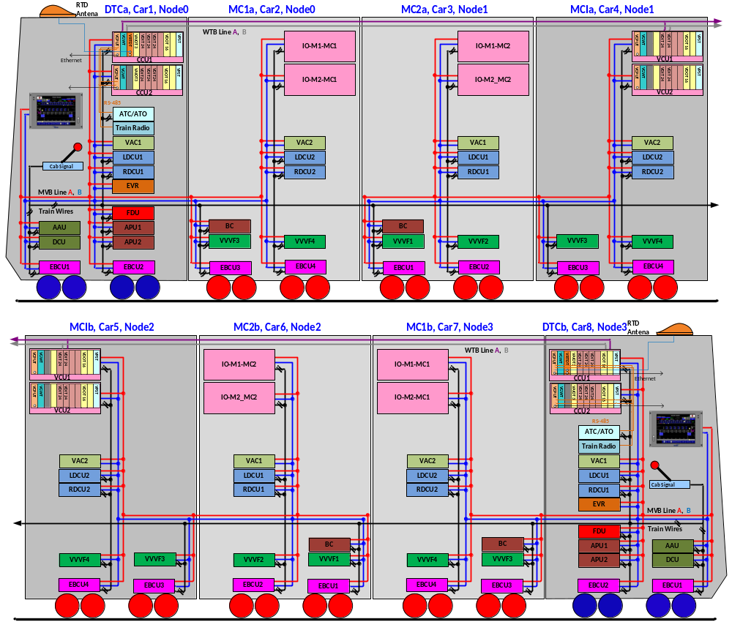

Figure 2 Configuration
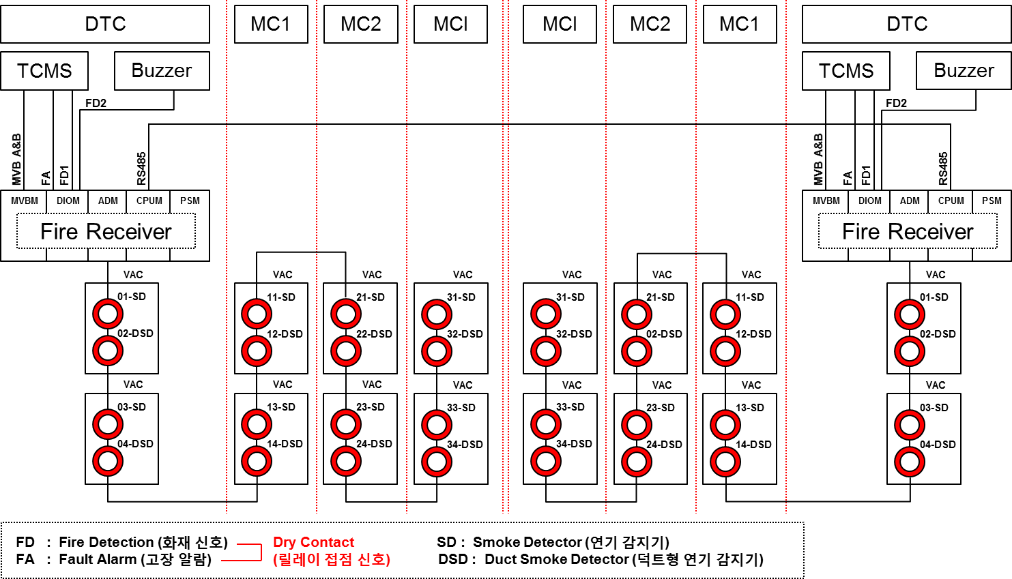

Figure 3 Configuration

DATA EXCHANGE

TCMS → FDU SDR (Status Data Request)
Telegram name | Source | Sink | Port address | Fcode | Task | Remark
TCMS-FDU-SDR | TCMS | FDU ALL | 0xCC | 4

TCMS-FDU-SDR
WORD | Data Contents |  |  |  |  |  |  |  | Remark
WORD | Bit Mask |  |  |  |  |  |  |  | Remark
WORD | 15 | 14 | 13 | 12 | 11 | 10 | 9 | 8
WORD | 7 | 6 | 5 | 4 | 3 | 2 | 1 | 0
0 | WatchDogCounterTCMS
1 | DateTimeYear
1 | DateTimeMonth
2 | DateTimeDay
2 | DateTimeHour
3 | DateTimeMinute
3 | DateTimeSec
4 | DateTimeValid |  |  |  | MVB_Node3(car7/8) | MVB_Node2(car5/6) | MVB_Node1(car3/4) | MVB_Node0(car1/2)
5 | Self Test  Request | Res. | Res. | Fire Release Request | Res. | Res. | Res. | Park Release Request
6
7
8
9
10
11
12
13
14
15

Bit  Offset | Data  Size | Data  Type | Data Name | Contents | Remarks
0 | 16 | UNSIGNED16 | TWatchDogCounterTCMS
16 | 8 | UNSIGNED8 | DateTimeYear | Year (00 – 99), | BCD
24 | 8 | UNSIGNED8 | DateTimeMonth | Month (1 – 12) | BCD
32 | 8 | UNSIGNED8 | DateTimeDay | Day (1 – 31) | BCD
40 | 8 | UNSIGNED8 | DateTimeHour | Hour (0 -23) | BCD
48 | 8 | UNSIGNED8 | DateTimeMinute | Minute (0 – 59) | BCD
56 | 8 | UNSIGNED8 | DateTimeSec | Second (0 – 59) | BCD
64 | 1 | BOOL | DateTimeValid | 0/1, 1 = Date & Time Validation
65 | 1 | BOOL
66 | 1 | BOOL
67 | 1 | BOOL
68 | 1 | BOOL | MVB_Node3(car7/8) | MVB NODE3 position(Refer to Fig2)
69 | 1 | BOOL | MVB_Node2(car5/6) | MVB NODE2 position(Refer to Fig2)
70 | 1 | BOOL | MVB_Node1(car3/4) | MVB NODE1 position(Refer to Fig2)
71 | 1 | BOOL | MVB_Node0(car1/2) | MVB NODE0 position(Refer to Fig2)
72 | 8 | UNSIGNED8
80 | 1 | BOOL | Self Test Request | 0/1, 1 = FDS executes the self-test.
81 | 1 | BOOL
82 | 1 | BOOL
83 | 1 | BOOL | Fire Release Request | 0/1, 1 = FDS releases the fire status.
84 | 1 | BOOL
85 | 1 | BOOL
86 | 1 | BOOL
87 | 1 | BOOL | Park Release Request | 0/1, 1 = FDS releases parking mode.

FDU → TCMS SD(Status Data)
Telegram name | Source | Sink | Port address | Fcode | Task | Remark
FDU-TCMS-SD1 | FDU | TCMS | 0xB0 | 4
FDU-TCMS-SD2 | FDU | TCMS | 0xB4 | 4
FDU-TCMS-SD3 | FDU | TCMS | 0xB8 | 4

FDU-TCMS-SD1
WORD | Data Contents |  |  |  |  |  |  |  | Remark
WORD | Bit Mask |  |  |  |  |  |  |  | Remark
WORD | 15 | 14 | 13 | 12 | 11 | 10 | 9 | 8
WORD | 7 | 6 | 5 | 4 | 3 | 2 | 1 | 0
0 | FDU_WatchdogCounter(0~65535)
1 | Self Test OK | Self Test NG | Self Test Progress |  | Res. | Res. | Res. | Res.
1 | Park Mode Status | Res. | Res. | Fire Release Ready | Res. | Res. | FDS  Location  Car8 | FDS  Location  Car1
2 | Res. | Res. | Res. | Res. | Res. | Res. | Res. | Res.
2 | Res. | Res. | Res. | Res. | Res. | Res. | Res. | Res.
3 | 14-DSD  Detector  Used | 13-SD  Detector  Used | 12-DSD  Detector  Used | 11-SD  Detector  Used | 04-DSD  Detector  Used | 03-SD  Detector  Used | 02-DSD  Detector  Used | 01-SD  Detector  Used
3 | 34-DSD  Detector  Used | 33-SD  Detector  Used | 32-DSD  Detector  Used | 31-SD  Detector  Used | 24-DSD  Detector  Used | 23-SD  Detector  Used | 22-DSD  Detector  Used | 21-SD  Detector  Used
4 | Res. | Res. | Res. | Res. | Res. | Res. | Res. | Res.
4 | Res. | Res. | Res. | Res. | Res. | Res. | Res. | Res.
5 | 04-DSD Detector Status  a_dtc_dsd2  B_dtc_dsd2 |  | 03-SD Detector Status  a_dtc_sd2  B_dtc_sd2 |  | 02-DSD Detector Status  a_dtc_dsd1  B_dtc_dsd1 |  | 01-SD Detector Status a_dtc_sd1  B_dtc_sd1
5 | 14-DSD Detector Status  a_mc1_dsd2  B_mc1_dsd2 |  | 13-SD Detector Status  A_mc1_sd2  B_mc1_sd2 |  | 12-DSD Detector Status  a_mc1_dsd1  B_mc1_dsd1 |  | 11-SD Detector Status  A_mc1_sd1  B_mc1_sd1
6 | 24-DSD Detector Status  A_mc2_dsd2  B_mc2_dsd2 |  | 23-SD Detector Status  A_mc2_sd2  B_mc2_sd2 |  | 22-DSD Detector Status  A_mc2_dsd1  B_mc2_dsd1 |  | 21-SD Detector Status  A_mc2_sd1  B_mc2_sd1
6 | 34-DSD Detector Status  A_mcI_dsd2  B_mcI_dsd2 |  | 33-SD Detector Status  A_mcI_sd2  B_mcI_sd2 |  | 32-DSD Detector Status  A_mcI_dsd1  B_mcI_dsd1 |  | 31-SD Detector Status  A_mcI_sd1  B_mcI_sd1
7 | Res. | Res. | Res. | Res. | Res. | Res. | Res. | Res.
7 | Res. | Res. | Res. | Res. | Res. | Res. | Res. | Res.
8 | Res. | Res. | Res. | Res. | Res. | Res. | Res. | Res.
8 | Res. | Res. | Res. | Res. | Res. | Res. | Res. | Res.
9 | 14-DSD  Detector  Check | 13-SD  Detector  Check | 12-DSD  Detector  Check | 11-SD  Detector  Check | 04-DSD  Detector  Check | 03-SD  Detector  Check | 02-DSD  Detector  Check | 01-SD  Detector  Check
9 | 34-DSD  Detector  Check | 33-SD  Detector  Check | 32-DSD  Detector  Check | 31-SD  Detector  Check | 24-DSD  Detector  Check | 23-SD  Detector  Check | 22-DSD  Detector  Check | 21-SD  Detector  Check
10 | Res. | Res. | Res. | Res. | Res. | Res. | Res. | Res.
10 | Res. | Res. | Res. | Res. | Res. | Res. | Res. | Res.
11 | Res. | Res. | Res. | Res. | Res. | Res. | Res. | Res.
11 | Res. | Res. | Res. | Res. | Res. | Res. | Res. | Res.
12 | Res. | Res. | Res. | Res. | Res. | Res. | Res. | Res.
12 | Res. | Res. | Res. | Res. | Res. | Res. | Res. | Res.
13 | Res. | Res. | Res. | Res. | Res. | Res. | Res. | Res.
13 | Res. | Res. | Res. | Res. | Res. | Res. | Res. | Res.
14 | Res. | Res. | Res. | Res. | Res. | Res. | Res. | Res.
14 | Res. | Res. | Res. | Res. | Res. | Res. | Res. | Res.
15 | Res. | Res. | Res. | Res. | Res. | Res. | Res. | Res.
15 | Res. | Res. | Res. | Res. | Res. | Res. | Res. | Res.

Bit  Offset | Data  Size | Data  Type | Data Name | Contents | Remarks
0 | 16 | UNSIGNED16 | FDU_WatchdogCounter | -. Range: 0 to 65535 (0000h to FFFFh)  -. FDU increments this bit every transmission cycle. TCMS ignores the information of SD if this counter is not incremented for more than "1000ms".
16 | 1 | BOOL | Self Test OK | Result of the FDS self-test  0/1, 1 = Self-Test OK
17 | 1 | BOOL | Self Test NG | Result of the FDS self-test  0/1, 1 = Self-Test NG
18 | 2 | - | Self Test Progress | Progress for the FDS self test  Range : 00h to 02h  0x00 = default  0x01 = progress  0x02 = Test complete
20 | 1 | BOOL
21 | 1 | BOOL
22 | 1 | BOOL
23 | 1 | BOOL
24 | 1 | BOOL | Park Mode Status | Operation mode of the FDS  (When the FDS is in the parking mode, fire detection is not performed.)  0/1, 1 = Parking mode
25 | 1 | BOOL
26 | 1 | BOOL
27 | 1 | BOOL | Fire Release Ready | This bit is set when it is possible to receive a fire release request from the TCMS after a fire  0/1, 1 = Fire Release Ready OK
28 | 1 | BOOL
29 | 1 | BOOL
30 | 1 | BOOL | FDS Location Car8 | Location information of FDS and active status  0/1, 1 = Car8(Status of FDS : Active)
31 | 1 | BOOL | FDS Location Car1 | Location information of FDS and active status  0/1, 1 = Car1(Status of FDS : Active)
32 | 8 | UNSIGNED8
40 | 8 | UNSIGNED8
48 | 1 | BOOL | 14-DSD Detector Used | Setting information of the FDS about whether or not the detector is used  0/1, 1 = Used
49 | 1 | BOOL | 13-SD Detector Used
50 | 1 | BOOL | 12-DSD Detector Used
51 | 1 | BOOL | 11-SD Detector Used
52 | 1 | BOOL | 04-DSD Detector Used
53 | 1 | BOOL | 03-SD Detector Used
54 | 1 | BOOL | 02-DSD Detector Used
55 | 1 | BOOL | 01-SD Detector Used
56 | 1 | BOOL | 24-DSD Detector Used
57 | 1 | BOOL | 23-SD Detector Used
58 | 1 | BOOL | 22-DSD Detector Used
59 | 1 | BOOL | 21-SD Detector Used
60 | 1 | BOOL | 34-DSD Detector Used
61 | 1 | BOOL | 33-SD Detector Used
62 | 1 | BOOL | 32-DSD Detector Used
63 | 1 | BOOL | 31-SD Detector Used
64 | 8 | UNSIGNED8
72 | 8 | UNSIGNED8
80 | 2 | - | 04-DSD Detector Status | Current state of each detector  Range : 00h to 03h  0x00 = Normal status  0x01 = Warning status  0x02 = Fire status  0x03 = Fault status
82 | 2 | - | 03-SD Detector Status
84 | 2 | - | 02-DSD Detector Status
86 | 2 | - | 01-SD Detector Status
88 | 2 | - | 14-DSD Detector Status
90 | 2 | - | 13-SD Detector Status
92 | 2 | - | 12-DSD Detector Status
94 | 2 | - | 11-SD Detector Status
96 | 2 | - | 34-DSD Detector Status
98 | 2 | - | 33-SD Detector Status
100 | 2 | - | 32-DSD Detector Status
102 | 2 | - | 31-SD Detector Status
104 | 2 | - | 24-DSD Detector Status
106 | 2 | - | 23-SD Detector Status
108 | 2 | - | 22-DSD Detector Status
110 | 2 | - | 21-SD Detector Status
112 | 8 | UNSIGNED8
120 | 8 | UNSIGNED8
128 | 8 | UNSIGNED8
136 | 8 | UNSIGNED8
144 | 1 | BOOL | 14-DSD Detector Check | 0/1, 1 = Detector needs to be checked
145 | 1 | BOOL | 13-SD Detector Check | 0/1, 1 = Detector needs to be checked
146 | 1 | BOOL | 12-DSD Detector Check | 0/1, 1 = Detector needs to be checked
147 | 1 | BOOL | 11-SD Detector Check | 0/1, 1 = Detector needs to be checked
148 | 1 | BOOL | 04-DSD Detector Check | 0/1, 1 = Detector needs to be checked
149 | 1 | BOOL | 03-SD Detector Check | 0/1, 1 = Detector needs to be checked
150 | 1 | BOOL | 02-DSD Detector Check | 0/1, 1 = Detector needs to be checked
151 | 1 | BOOL | 01-SD Detector Check | 0/1, 1 = Detector needs to be checked
152 | 1 | BOOL | 34-DSD Detector Check | 0/1, 1 = Detector needs to be checked
153 | 1 | BOOL | 33-SD Detector Check | 0/1, 1 = Detector needs to be checked
154 | 1 | BOOL | 32-DSD Detector Check | 0/1, 1 = Detector needs to be checked
155 | 1 | BOOL | 31-SD Detector Check | 0/1, 1 = Detector needs to be checked
156 | 1 | BOOL | 24-DSD Detector Check | 0/1, 1 = Detector needs to be checked
157 | 1 | BOOL | 23-SD Detector Check | 0/1, 1 = Detector needs to be checked
158 | 1 | BOOL | 22-DSD Detector Check | 0/1, 1 = Detector needs to be checked
159 | 1 | BOOL | 21-SD Detector Check | 0/1, 1 = Detector needs to be checked

FDU-TCMS-SD2
WORD | Data Contents |  |  |  |  |  |  |  | Remark
WORD | Bit Mask |  |  |  |  |  |  |  | Remark
WORD | 15 | 14 | 13 | 12 | 11 | 10 | 9 | 8
WORD | 7 | 6 | 5 | 4 | 3 | 2 | 1 | 0
0 | FDU_WatchdogCounter(0~65535)
1 | 01-SD Detector Analogue Value
1 | 02-DSD Detector Analogue Value
2 | 03-SD Detector Analogue Value
2 | 04-DSD Detector Analogue Value
3 | 11-SD Detector Analogue Value
3 | 12-DSD Detector Analogue Value
4 | 13-SD Detector Analogue Value
4 | 14-DSD Detector Analogue Value
5 | 21-SD Detector Analogue Value
5 | 22-DSD Detector Analogue Value
6 | 23-SD Detector Analogue Value
6 | 24-DSD Detector Analogue Value
7 | 31-SD Detector Analogue Value
7 | 32-DSD Detector Analogue Value
8 | 33-SD Detector Analogue Value
8 | 34-DSD Detector Analogue Value
9 | Res. | Res. | Res. | Res. | Res. | Res. | Res. | Res.
9 | Res. | Res. | Res. | Res. | Res. | Res. | Res. | Res.
10 | Res. | Res. | Res. | Res. | Res. | Res. | Res. | Res.
10 | Res. | Res. | Res. | Res. | Res. | Res. | Res. | Res.
11 | Res. | Res. | Res. | Res. | Res. | Res. | Res. | Res.
11 | Res. | Res. | Res. | Res. | Res. | Res. | Res. | Res.
12 | Res. | Res. | Res. | Res. | Res. | Res. | Res. | Res.
12 | Res. | Res. | Res. | Res. | Res. | Res. | Res. | Res.
13 | Res. | Res. | Res. | Res. | Res. | Res. | Res. | Res.
13 | Res. | Res. | Res. | Res. | Res. | Res. | Res. | Res.
14 | Res. | Res. | Res. | Res. | Res. | Res. | Res. | Res.
14 | Res. | Res. | Res. | Res. | Res. | Res. | Res. | Res.
15 | Res. | Res. | Res. | Res. | Res. | Res. | Res. | Res.
15 | Res. | Res. | Res. | Res. | Res. | Res. | Res. | Res.

Bit  Offset | Data  Size | Data  Type | Data Name | Contents | Remarks
0 | 16 | UNSIGNED16 | FDU_WatchdogCounter | -. Range: 0 to 65535 (0000h to FFFFh)  -. FDU increments this bit every transmission cycle. TCMS ignores the information of SD if this counter is not incremented for more than "1000ms".
16 | 8 | UNSIGNED8 | 01-SD Detector Analogue Value | Current measurement level received from each detector. It is the data necessary to judge a fire.  (Above 45 : Warning level, Above 55 : Fire level)
24 | 8 | UNSIGNED8 | 02-DSD Detector Analogue Value
32 | 8 | UNSIGNED8 | 03-SD Detector Analogue Value
40 | 8 | UNSIGNED8 | 04-DSD Detector Analogue Value
48 | 8 | UNSIGNED8 | 11-SD Detector Analogue Value
56 | 8 | UNSIGNED8 | 12-DSD Detector Analogue Value
64 | 8 | UNSIGNED8 | 13-SD Detector Analogue Value
72 | 8 | UNSIGNED8 | 14-DSD Detector Analogue Value
80 | 8 | UNSIGNED8 | 21-SD Detector Analogue Value
88 | 8 | UNSIGNED8 | 22-DSD Detector Analogue Value
96 | 8 | UNSIGNED8 | 23-SD Detector Analogue Value
104 | 8 | UNSIGNED8 | 24-DSD Detector Analogue Value
112 | 8 | UNSIGNED8 | 31-SD Detector Analogue Value
120 | 8 | UNSIGNED8 | 32-DSD Detector Analogue Value
128 | 8 | UNSIGNED8 | 33-SD Detector Analogue Value
136 | 8 | UNSIGNED8 | 34-DSD Detector Analogue Value

FDU-TCMS-SD3
WORD | Data Contents |  |  |  |  |  |  |  | Remark
WORD | Bit Mask |  |  |  |  |  |  |  | Remark
WORD | 15 | 14 | 13 | 12 | 11 | 10 | 9 | 8
WORD | 7 | 6 | 5 | 4 | 3 | 2 | 1 | 0
0 | FDU_WatchdogCounter(0~65535)
1 | Res. | Res. | Res. | Res. | Res. | Res. | Res. | Res.
1 | Res. | Res. | Res. | Res. | Res. | Res. | Res. | Res.
2 | Checksum Fault | Memory Fault | Detector Fault | Switch  Fault | Internal Temperature Alarm | Res. | Fire Detect  Car8 | Fire Detect  Car1
2 | Res. | Res. | Res. | Res. | Res. | Res. | Res. | Res.
3 | Version 00.X0 (BCD, 0 - 9) |  |  |  | Version 00.0X (BCD, 0 - 9) |  |  |  | Main CPUM Version
3 | Version X0.00 (BCD, 0 - 9) |  |  |  | Version 0X.00 (BCD, 0 - 9) |  |  |  | Main CPUM Version
4 | Res. | Res. | Res. | Res. | Res. | Res. | Res. | Res.
4 | Res. | Res. | Res. | Res. | Res. | Res. | Res. | Res.
5 | Res. | Res. | Res. | Res. | Res. | Res. | Res. | Res.
5 | Res. | Res. | Res. | Res. | Res. | Res. | Res. | Res.
6 | Res. | Res. | Res. | Res. | Res. | Res. | Res. | Res.
6 | Res. | Res. | Res. | Res. | Res. | Res. | Res. | Res.
7 | Res. | Res. | Res. | Res. | Res. | Res. | Res. | Res.
7 | Res. | Res. | Res. | Res. | Res. | Res. | Res. | Res.
8 | Res. | Res. | Res. | Res. | Res. | Res. | Res. | Res.
8 | Res. | Res. | Res. | Res. | Res. | Res. | Res. | Res.
9 | Res. | Res. | Res. | Res. | Res. | Res. | Res. | Res.
9 | Res. | Res. | Res. | Res. | Res. | Res. | Res. | Res.
10 | Res. | Res. | Res. | Res. | Res. | Res. | Res. | Res.
10 | Res. | Res. | Res. | Res. | Res. | Res. | Res. | Res.
11 | Res. | Res. | Res. | Res. | Res. | Res. | Res. | Res.
11 | Res. | Res. | Res. | Res. | Res. | Res. | Res. | Res.
12 | Res. | Res. | Res. | Res. | Res. | Res. | Res. | Res.
12 | Res. | Res. | Res. | Res. | Res. | Res. | Res. | Res.
13 | Res. | Res. | Res. | Res. | Res. | Res. | Res. | Res.
13 | Res. | Res. | Res. | Res. | Res. | Res. | Res. | Res.
14 | Res. | Res. | Res. | Res. | Res. | Res. | Res. | Res.
14 | Res. | Res. | Res. | Res. | Res. | Res. | Res. | Res.
15 | Res. | Res. | Res. | Res. | Res. | Res. | Res. | Res.
15 | Res. | Res. | Res. | Res. | Res. | Res. | Res. | Res.

Bit  Offset | Data  Size | Data  Type | Data Name | Contents | Remarks
0 | 16 | UNSIGNED16 | FDU_WatchdogCounter | -. Range: 0 to 65535 (0000h to FFFFh)  -. FDU increments this bit every transmission cycle. TCMS ignores the information of SD if this counter is not incremented for more than "1000ms".
16 | 16 | UNSIGNED16
32 | 1 | BOOL | Checksum Fault | 0/1, 1 = CRC of the program code is not correct.
33 | 1 | BOOL | Memory Fault | 0/1, 1 = FRAM initialization fails
34 | 1 | BOOL | Detector Fault | 0/1, 1 = One or more detectors fault
35 | 1 | BOOL | Switch Fault | 0/1, 1 = Home button is pressed while FDS is booting
36 | 1 | BOOL | Internal Temperature Alarm | 0/1,  1 = (Temperature > 85℃ or Temperature < -40℃)
37 | 1 | BOOL
38 | 1 | BOOL | Fire Detect Car8 | 0/1, 1 = One or more detectors detect a fire in FDS of Car8
39 | 1 | BOOL | Fire Detect Car1 | 0/1, 1 = One or more detectors detect a fire in FDS of Car1
40 | 8 | UNSIGNED8
48 | 8 | UNSIGNED8 | Version Minor | Software version of CPUM (00 ~ 99) | BCD
56 | 8 | UNSIGNED8 | Version Major | Software version of CPUM (00 ~ 99) | BCD

